MEDIA RELEASE

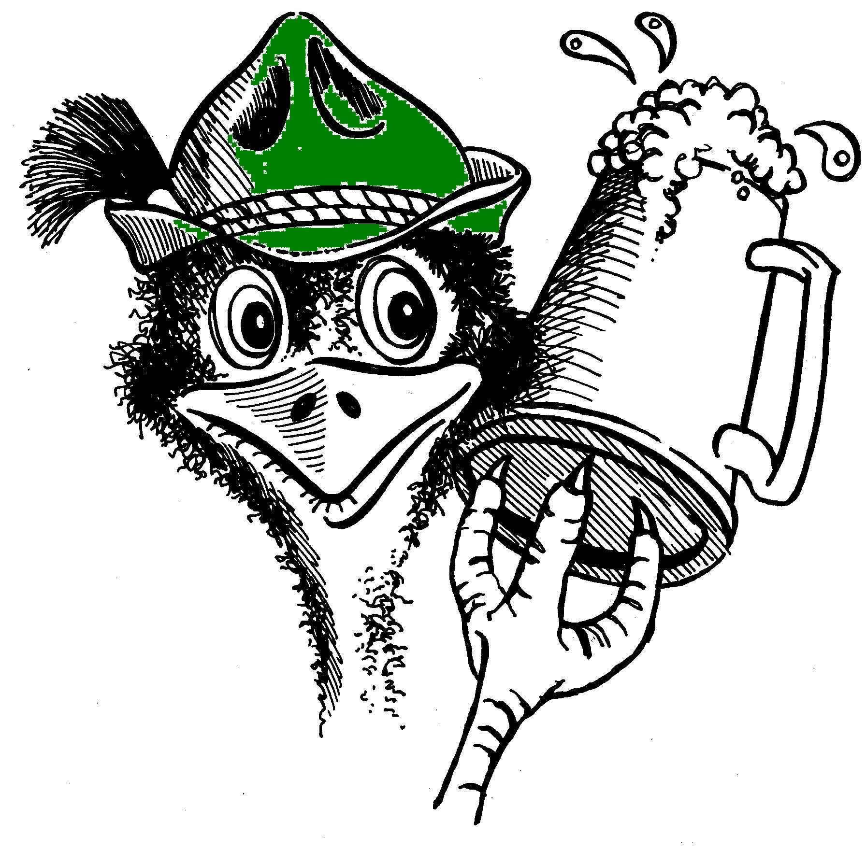
Emu Park Lions
Bell Park, Emu Park
Saturday, 28th October

OKTOBERFEST

The Emu Park Lions are set to ignite Emu Park with their 38th annual Oktoberfest at Bell Park on October 28th, from 11am to 10 pm. Get ready to experience the OOM-PAH-PAH like never before!`

Oktoberfest enthusiasts will be thrilled to witness the return of Australia's premier German show band, "The Kalendar Band," the yodeling sensation "Heidi," and the jazzy tunes of Tommy Nicholson. This talented ensemble will captivate you with their traditional floor show, featuring OOM-PAH-PAH, Bavarian folk dancing, cowbells, Swiss Alp Horn, yodeling, and spirited German beer-drinking songs. Prepare for knee-slapping, toe-tapping, slap dancing, hat dancing, and even chicken dancing – it's a show like no other. Their beautiful German ballads will also keep you enchanted.

This year, "Dawn & The Sax" will also grace the Oktoberfest stage, joined by Peter Field on guitar, offering a diverse range of music including soul, R&B, jazz, pop, and rock.

Gather your friends, join the lively crowd, and don your best Bavarian attire, from dirndls and lederhosen to Bavarian alpine hats and dancing shoes. Dress to impress, and you might just be crowned the best-dressed prince or princess. Test
your vocal prowess in Heidi's yodeling challenge and indulge in traditional German delicacies such as sausages, kartoffelpuffers, apfelstrudel, and imported biers.

Don't forget to grab a raffle ticket for a chance to win one of three fantastic prizes, including two nights' accommodation at Heron Island, Great Keppel Island Hideaway, or Oshen Apartments Yeppoon. Pre-sale tickets are also available outside Drakes Supermarket in Emu Park.

For event rules and bus services, visit the Oktoberfest website. Ensure you organize transportation and accommodation in advance to stay safe and avoid drinking and driving.

Thanks to CDC Queensland (formerly Youngs Bus Service), services additional to the usual Saturday service will be available, making it convenient for everyone to attend - from Zilzie 3.00pm & 5:00pm; to Zilzie 9.10pm & 9.40pm; to Yeppoon 9.30pm & 9.45pm; & 3 services to Rockhampton (via Zilzie & Yeppoon) at 10.30pm. There will be three Zilzie pick-up & drop-off points, so getting there is a breeze – near Fire Brigade on Hartley St; cnr Hartley & Claude Sts & Svendsens Rd; & near the golf clubhouse in Monaco Dr Zilzie Bay.

Please note that strict licensing laws will be enforced, and outside alcohol is not allowed. Only sealed bottles of water or diabetic drinks will be permitted. Bags may be subject to inspection, and age verification will be required. Minors must be accompanied by a responsible adult, and no one under 18 is allowed in the licensed area after 6:00 pm. Leave your pets and eskies at home. Pass outs will be available for those who want to leave and return, and there will be ATM facilities on-site.

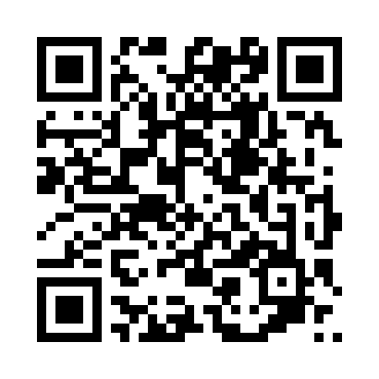
So, come and immerse yourself in the rich culture of Bavaria and enjoy an incredible day. Where else can you find such fantastic entertainment at such an affordable price?
In brief:
Event: Emu Park Oktoberfest
Where: Bell Park, Emu Park
When: Saturday, 28th October – 11am-10pm [Persons under the age of 18 are not permitted after 6:00pm] Pass outs are allowed
Tickets:Tickets available on https://www.trybooking.com/CJSMX or at the gate
Cost: 18 years plus-$25; Pensioners-$20(at the gate); 15-18 years-$5; under 15-free.
Web: http://www.emuparkoktoberfest.com

